***Shopnest Store Power BI Capstone***

**1. Top Categories by Total Price:**

• Identify and visually represent the top 10 product categories by total sales.  
  
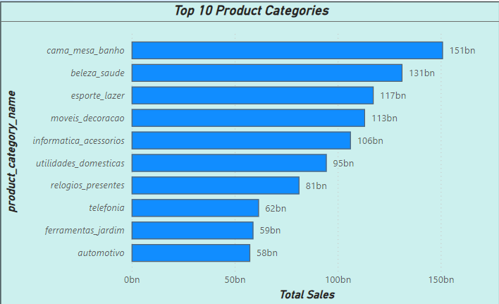  
  
The graph show the top 10 product categories with their total sales. Here top-selling product category is "Cama, Mesa, Banho" with 151Bn in sales, followed by "Beleza e Saude" with 131Bn.  
  
  
**2. Delayed Orders Analysis:**

• Determine the number of delayed orders in each category. An order is considered delayed if the actual delivery date is later than the estimated delivery date.

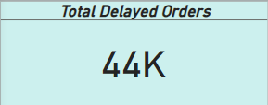

With this visualization we can see that we have total of 44k of delayed orders out of 99k orders

**3. Monthly Comparison of Delayed and On-Time Orders:**

• Create a dynamic visual that compares the number of delayed orders to the number of orders received earlier for each month. Utilize the drillthrough cross-report feature to provide a detailed analysis of late and on-time deliveries.

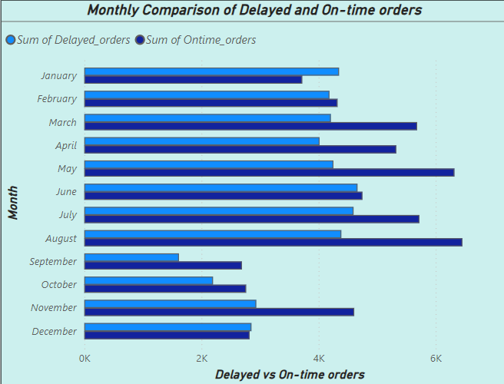

With this graph we have compared the number of delayed and on-time orders for each month. Comparing the graph, here we can see that highest delays is in September and May, while on-time orders are consistently high throughout the year.I have used drill-through feature so that we can get detailed insight.

**4. Payment Method Analysis:**

• Analyze the most frequently used payment methods by customers using a visually appealing representation, such as a pie chart or other suitable visuals.

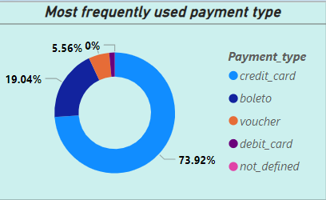

This visualization indicated the frequently used payment method by customers. 73.92% indicates  “credit_card” usage being 1st most used mode and 2nd most used mode will be "boleto" with 19.04%

**5. Product Rating Analysis:**

• Determine the top 10 highest-rated products and the bottom 10 lowest-rated products using a bar or column chart.

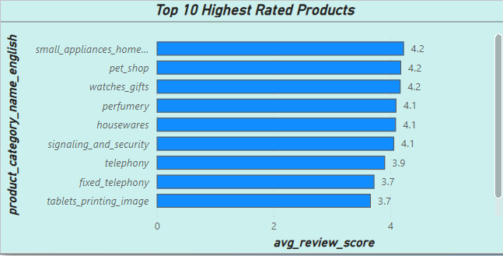  
  
The graph indicates the top 10 highest-rated products based on their average review score. "small_appliances_home." has the highest rating of 4.2, while "tablets_printing_image" has the lowest rating of 3.7.

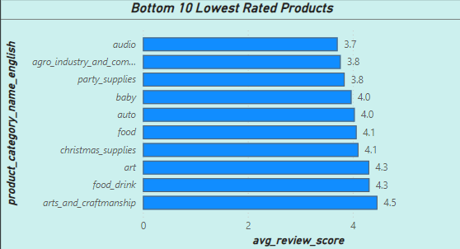

The graph indicates the bottom 10 lowest-rated products according to their average review score. "audio" is rated the lowest at 3.7, and "arts_and_craftmanship" has the highest rating at 4.5.

**6. State-wise Sales Analysis:**

• Identify and visually represent states with high and low sales, providing a clear understanding of regional sales performance.

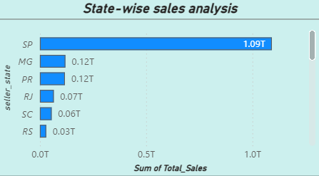

The graph displays state-wise sales analysis. SP has the highest sales at 1.09T, followed by MG and PR at 0.12T each. RS has the lowest sales at 0.03T.

**7. Seasonal Sales Patterns:**

• Investigate and visualize any seasonal patterns(Quarterly) or trends in sales data over the course of the year.

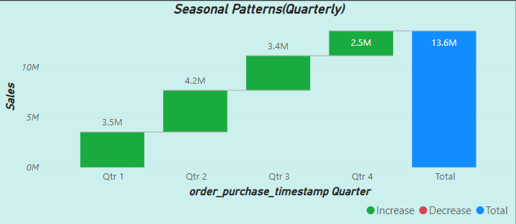This graph represents quarterly sales figures. Qtr 4 recorded the highest sales at 13.6M and Qtr 1 at 3.5M as the lowest. The graph indicates that sales had decreased in the first three quarters but increased highly in the fourth quarter.

**8. Revenue Analysis:**

• Determine the total revenue generated by ShopNest Store and analyze how it changes over time(Yearly). Represent this information through suitable visuals to highlight trends and patterns.  
  
  
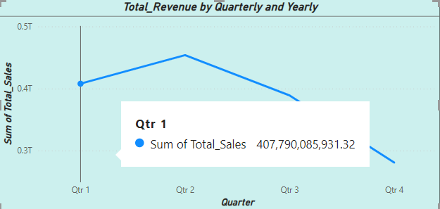  
  
This graph gives insights of quarterly revenues.The highest revenue, that too of Qtr 2 followed by Qtr 1. Revenue is substantially dipped in Qtr 3 and further in Qtr 4.